[COMPUTER VISION AND PATTERN RECOGNITION [C]](https://portal.aiub.edu/Student/Section?q=ZGNZ55p%2FrDvdhSZrbcFYvA%3D%3D)

ASSIGNMENT-1[FINAL TERM]

Student Name: Shahriar Hossain Rafi

Student ID: 20-42528-1

Submitted to: DR. DEBAJYOTI KARMAKER

In this Assignment A CNN model has been build using sequential neural network architecture.

**Step-1: First we imported needed libraries**

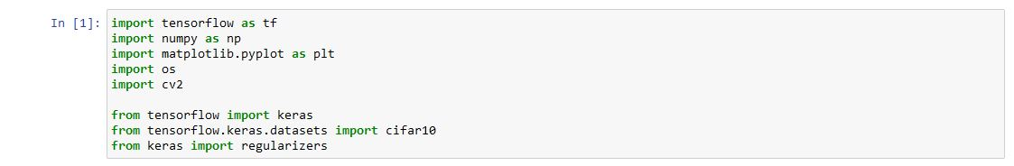

**Step-2: Then we downloaded the dataset CIFER-10 and load it and listing the class names.**

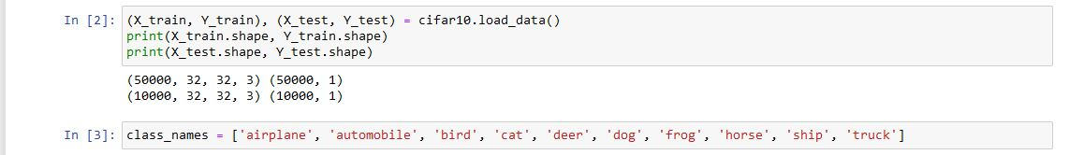

**Step-3: Load the Data from dataset using plot**

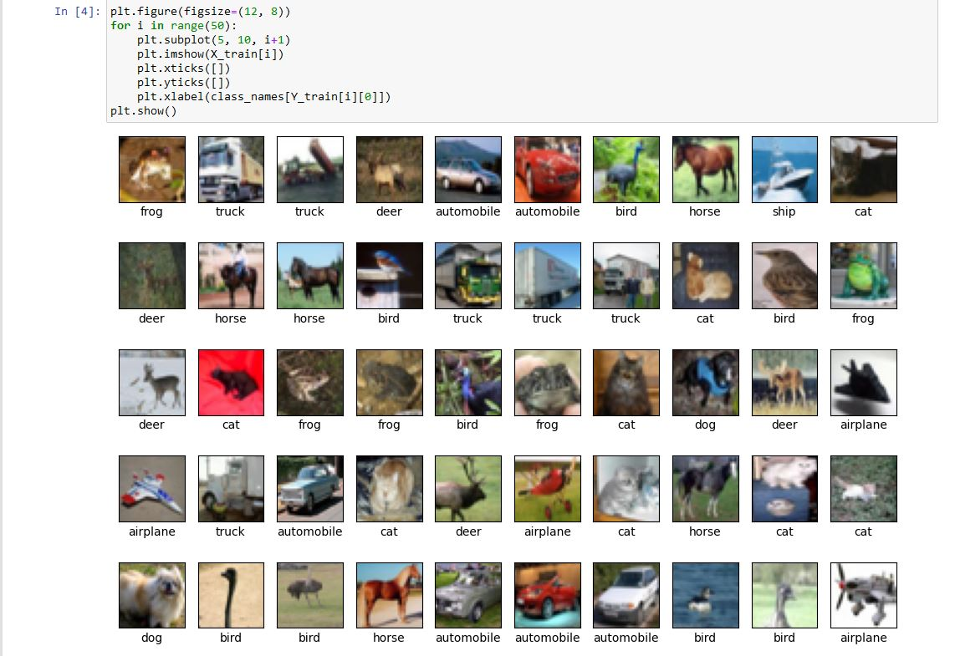

**Step-4: Building the NEURAL NETWORK SEQUENTIAL MODEL.**

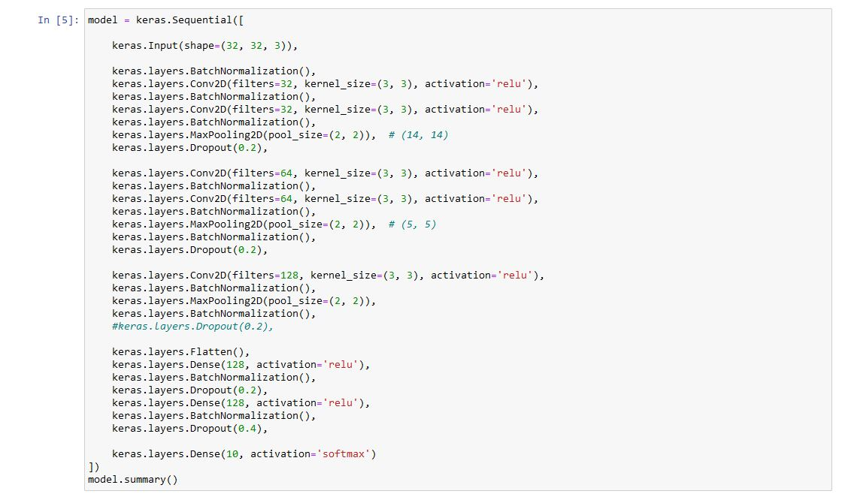

**Step-5: Using Optimizers and Tuning the Hyperparameters for SGD**

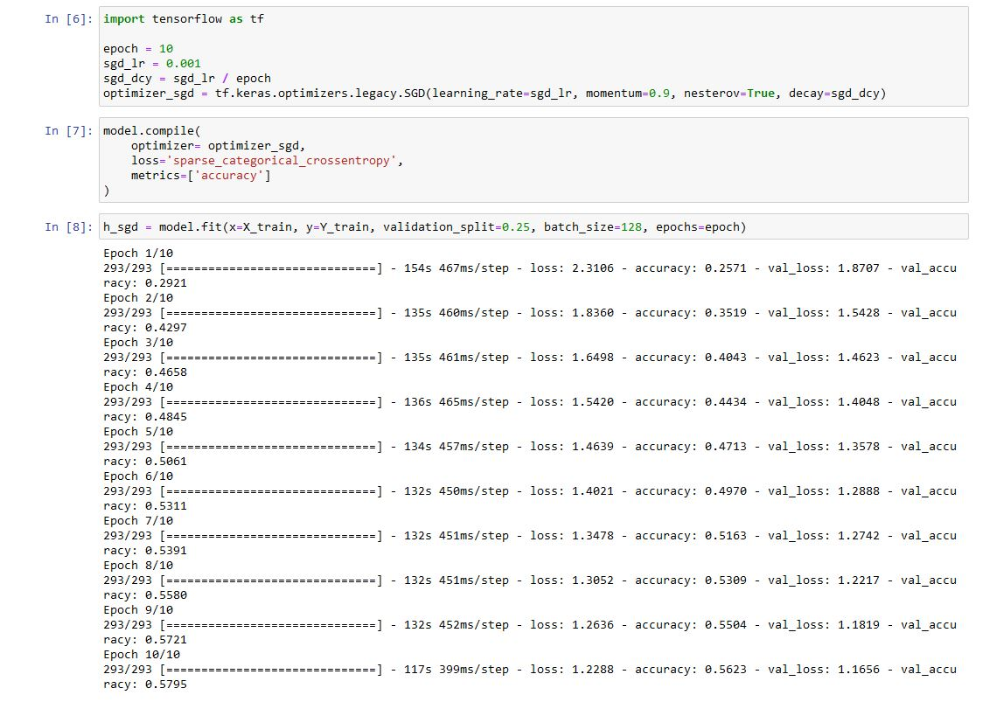

**Step-6: Getting the SGD Performance on Validation Testing on Unseen Data for SGD Optimizer**

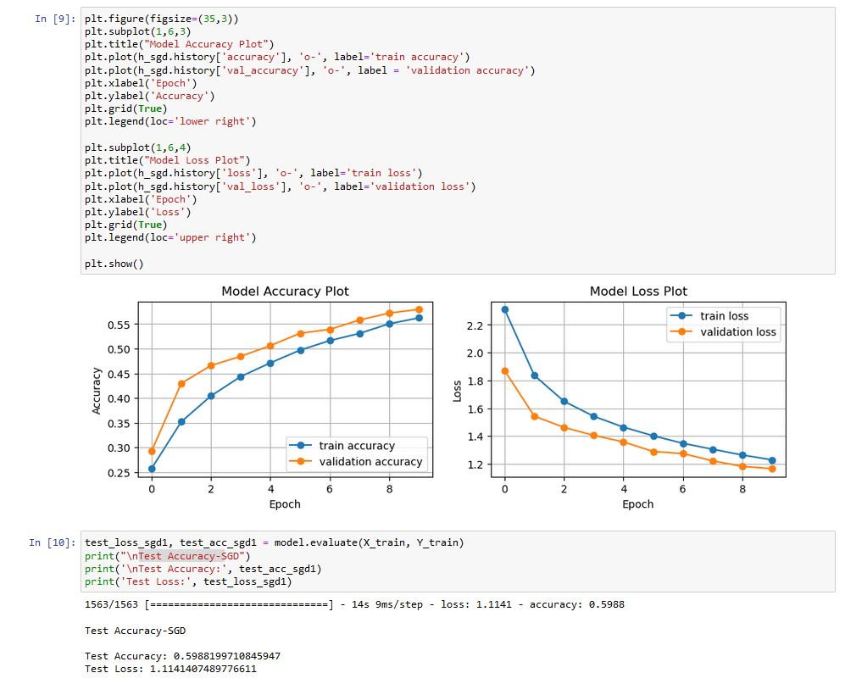

**Step-7: Using Optimizers and Tuning the Hyperparameters for RMSProp**

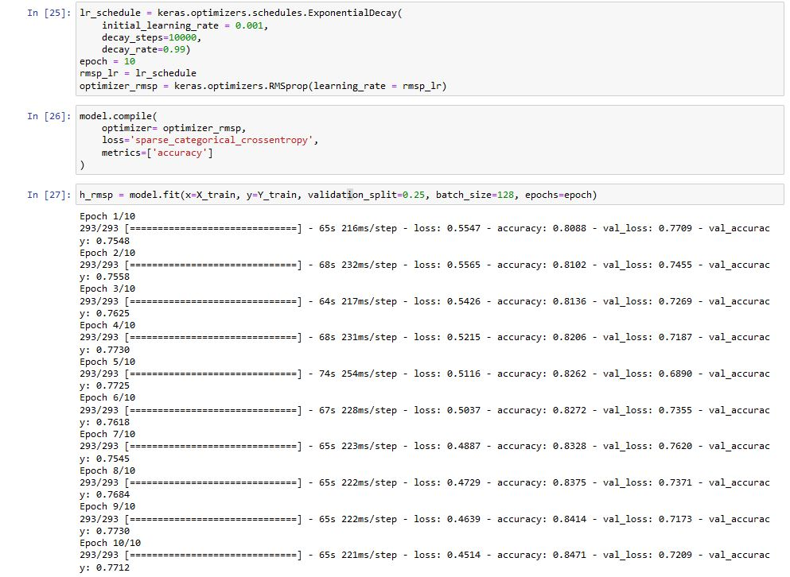

**Step-8: Getting the RMSProp Performance on Validation Testing on Unseen Data for RMSProp Optimizer**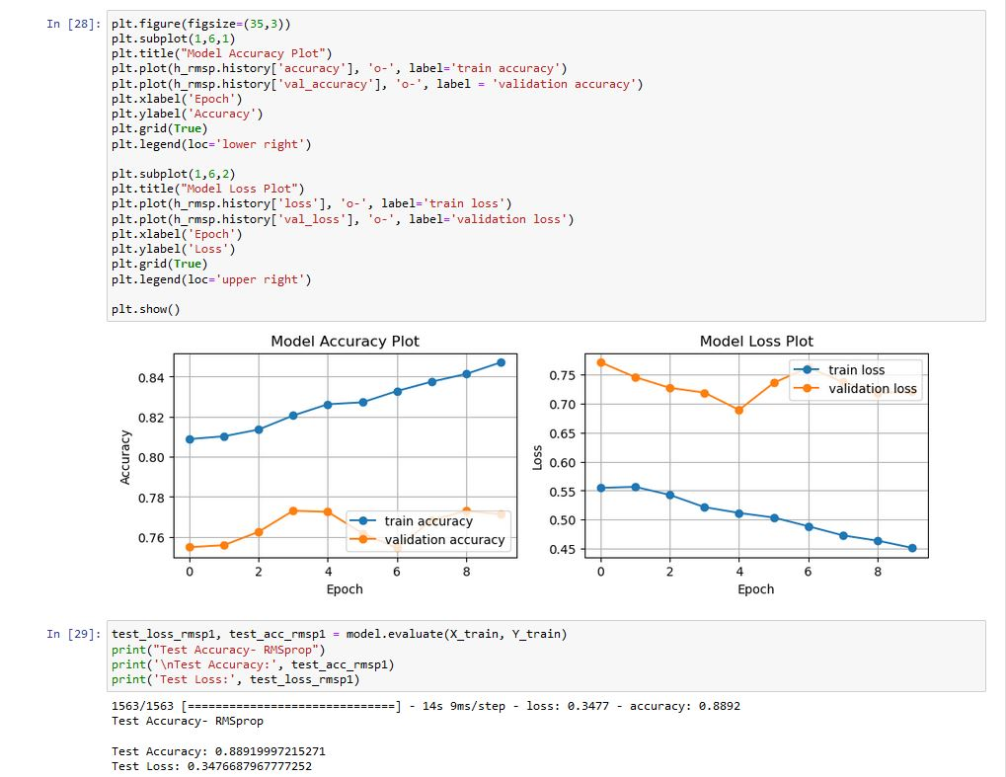

**Step-7: Using Optimizers and Tuning the Hyperparameters for Adam**

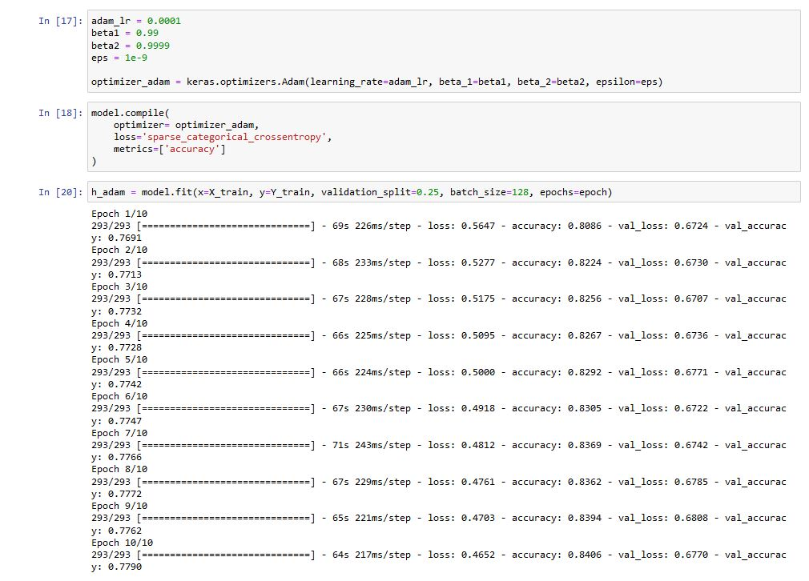

**Step-8: Getting the Adam Performance on Validation Testing on Unseen Data for Adam Optimizer**

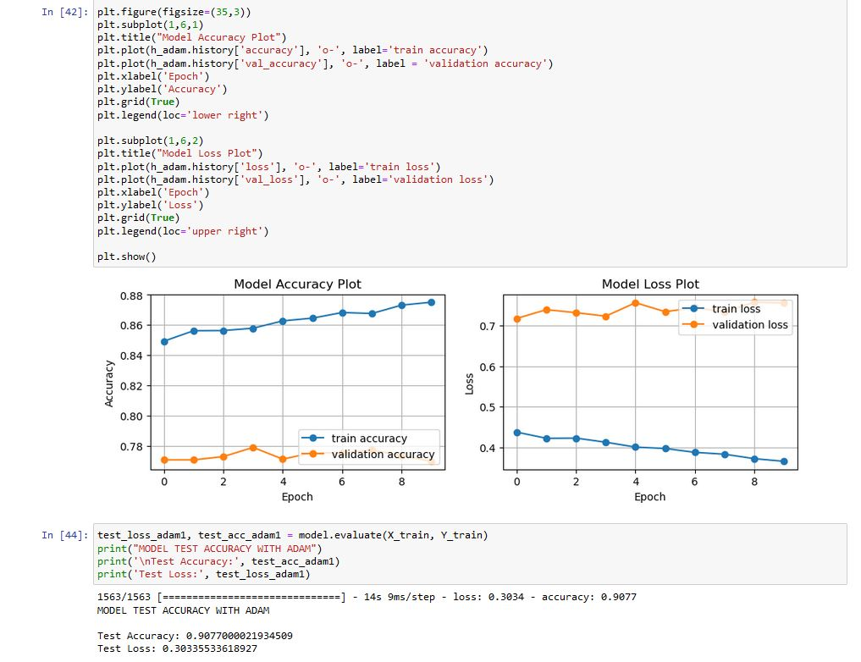

**Step-9 finding the RESULTS**

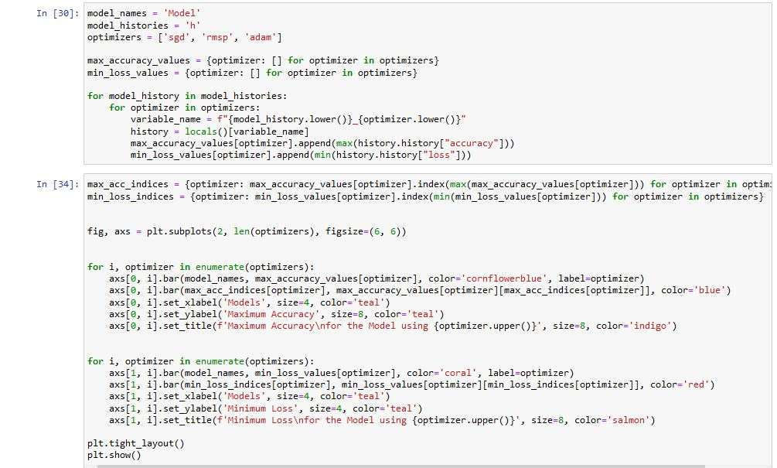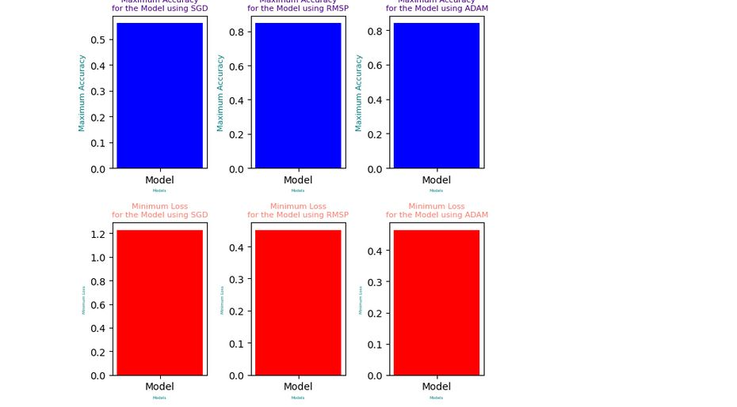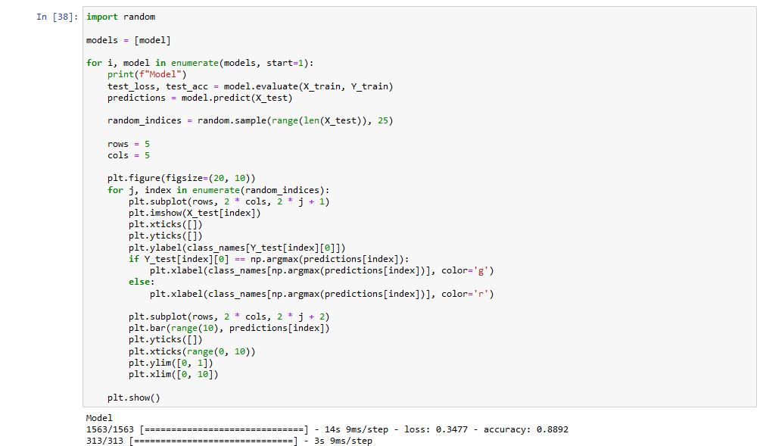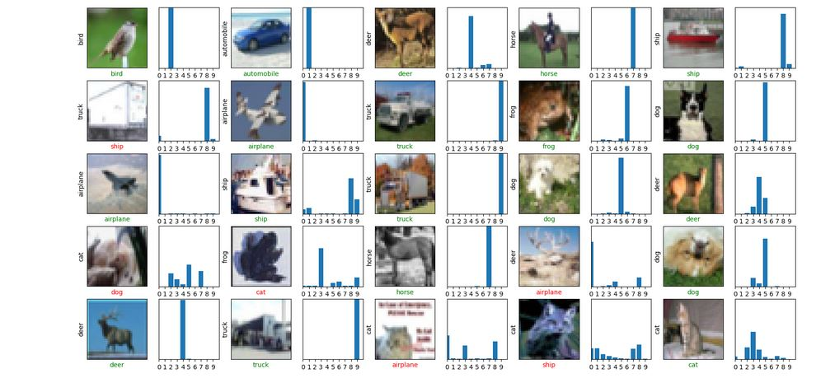

**Discussion:**

The model was built focusing on maximum accuracy and minimum loss. The model was built to keep it from overfitting was also considered a primary objective. After all the training, testing, predicting and evaluating, we can see that in our model for SGD optimization test accuracy was 0.6855999827384949 and test loss was 2.178375482559204.for RMSProp optimization test accuracy was 0.71670001745224 and test loss was 1.8310835361480713. for Adam optimization test accuracy was 0.7843000292778015 and test loss was 1.0654267072677612.the Adam optimization algorithm achieved the highest test accuracy (0.7843000292778015) and the lowest test loss (1.0654267072677612) among the three options. This indicates that the model trained using Adam optimization performed better than the models trained using SGD and RMSProp optimizations for the given task. Therefore, based on the provided results, Adam optimization was the better choice for achieving higher accuracy and lower loss in this specific scenario.